### **The Twelve Days of Christmas Ornaments**

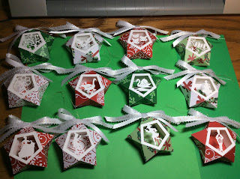

The Christmas season is upon us and I am decorating my tree with paper ornaments. I made ornaments depicting the twelve days of Christmas. The twelve days of Christmas begins with the birth of Christ on December 25 and ends on the Feast of Ephiphany, January 6. This is the day that the three wise men of the East (Magi) follow the Star of Bethlehem to worship him and give him gifts.  
  
The song the "Twelve Days of Christmas" was the inspiration for these ornaments. The scenes shown in the three dimensional star are:

A Partridge in a Pear Tree

Two Turtle Doves

Three French Hens

Four Calling Birds

Five Golden Rings

Six Geese a Laying

Seven Swans a Swimming

Eight Maids a Milking

Nine Ladies Dancing

Ten Lords a Leaping

Eleven Pipers Piping

Twelve Drummers Drumming

The ornaments have 3/8 inch wide ribbons which were Foil Quilled with the words of the scene.

I used a Christmas paper pad for the star and 65 lb. white paper for the scenery insert.

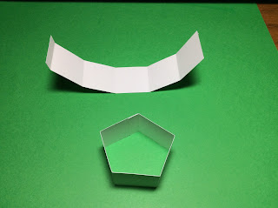

Cut out 12 strips and fold them all into a pentagon.

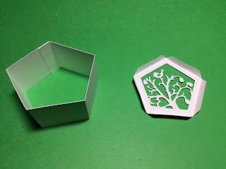

Bend the tabs of the scene and apply glue to the inner edges.

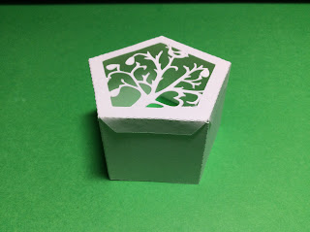

Adhere the scene to the pentagon. Repeat for the remaining scenes.

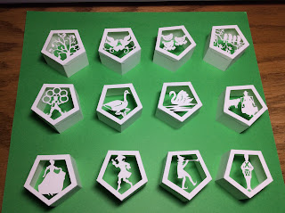

Completed scenery inserts.

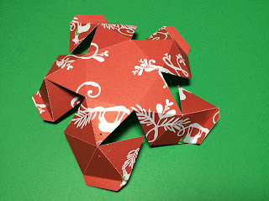

Bend the star as shown above.

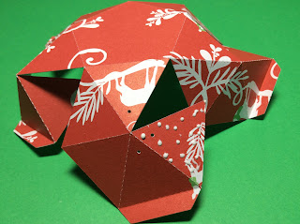

Apply glue to the triangle without a tab as shown above. Adhere to form a pyramid.

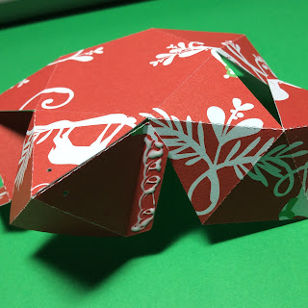

Apply glue to the pyramid tab and adhere it to the adjacent triangle.

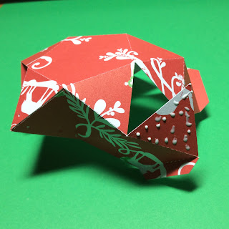

Repeat the process of glueing the triangle tab.

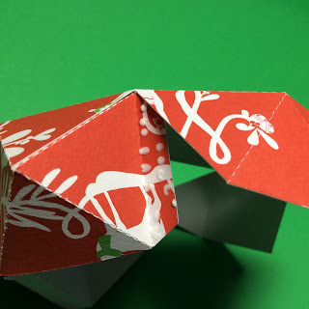

And the pyramid tab until the star is completed.

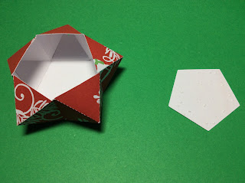

Put glue on the back of the pentagon piece on the right.

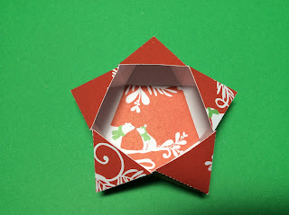

Adhere this scene to the back of the star.

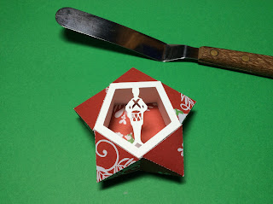

Insert the scene into the star by aligning the scene with the hole in the star at the top. You might need to crimp the pentagon a little and use a knife to guide the scene into the star.

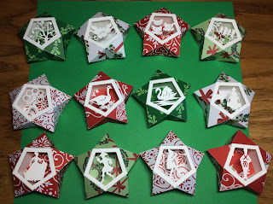

Completed stars with their scenery inserted.

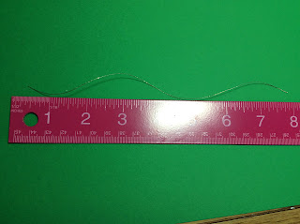

Cut an eight inch piece of string.

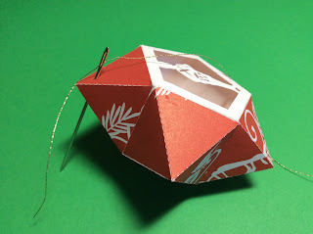

Using a needle thread the string through the hole at the top.

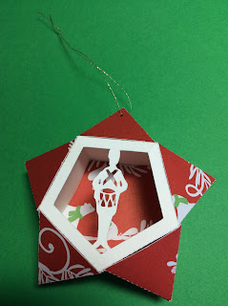

Tie a knot at the top of the string to make a loop.

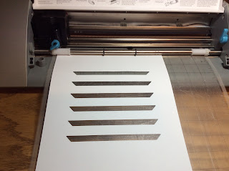

Using the Ribbon file for the Foil Quill, follow the directions in the file. The blue lines are the cut lines and the red lines are the sketch lines when you Send the file for action to be performed.

Insert a piece of cardstock into your Cameo and send the file to cut out the blue lines(uncheck the red lines). Do not unload the paper when the machine has completed the cut. Above you will see that the paper is still loaded and the six areas where the cut was made, have been removed.

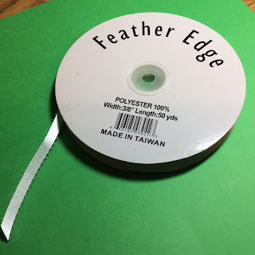

Here is the 3/8 inch ribbon that I used.

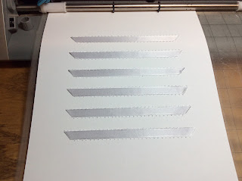

Using the removed cut outs, cut six ribbons and adhere each one to the mat.

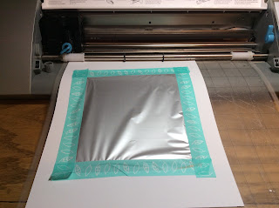

Tape on the foil. (The foil in the photo above is not correct...it was taped on the wrong side.) The gold foil must be showing. (I forgot to take another photo once I corrected my mistake.) Insert your Foil Quill to the pen holder as per the manufacturers instructions, send the file to sketch the red lines in the file to Foil Quill the ribbon(uncheck the blue lines).

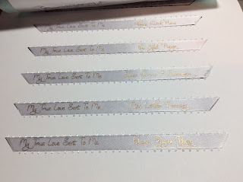

Foil Quilled ribbons. You can now unload the machine. Keep the foil as you will be using it for the second half of the ribbons.



Repeat for the next six ribbons. Load the machine and cut out the second half of the spots.



Do not unload the machine. Adhere the ribbons.

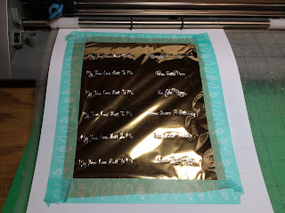

Attach the foil. Make sure that clean foil is aligned to the ribbon areas. Foil Quill the ribbons.

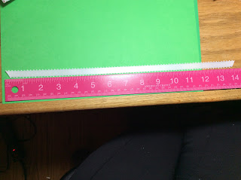

Cut out a fourteen inch piece of ribbon for the bow.

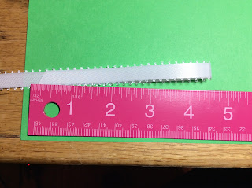

Bend the ribbon at 4 1/2 inches and begin to make the bow. Do not pull it tight yet.

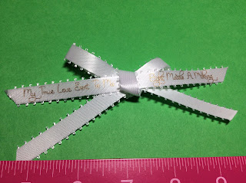

Insert the Foil Quilled ribbon into the knot and then make the knot tighter.

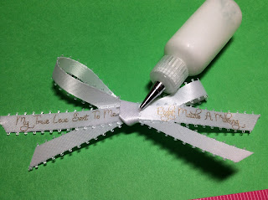

Apply a drop of glue under the knot.

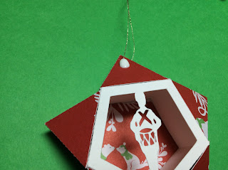

Apply a substantial amount of glue to the top of the ornament as shown above.

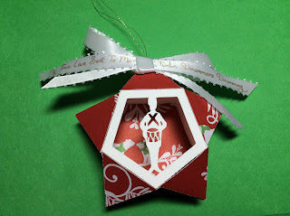

Adhere the bow to the glue.



Completed ornaments.